Content

- YouTube_MLOps_Project ……………………………………………………………………………… 2
  - MLOps ….……………………………………………………………………………………………
  - CI/CD (GitHub Action) …………………………………………………………………………
  - Kubernetes …………………………………………………………………………………………
  - Automation_Pipeline (AWS Sagemaker) ………….…………………………………
  - Monitoring (Grafana) ……….………………………………………………………………..

1. YouTube_Sentiment_Insights_MLOps_Project
Note: We will follow a traditional Machine Learning approach. However, for better performance, we can also consider using an NLP-based approach with modern LLMs.

- Proposed Solution
We will build a Chrome extension that, whenever a YouTube video is opened, automatically detects the video, extracts all the comments, and generates a sentiment analysis dashboard for the user.

- Plan of the Project
- Data Collection: We will use a predefined dataset from Reddit for training.
Kaggle: https://www.kaggle.com/code/akulez/reddit-sentiment-analysis

Download: https://raw.githubusercontent.com/Himanshu-1703/reddit-sentiment-analysis/refs/heads/main/data/reddit.csv
NOTE: There are three categories i.e.
- 1 – Positive
- -1 – Negative
- 0 – Neutral

- SetUp MLFlow Server on AWS - (5hr 13min)
We will not use DagsHub because we want a fully private tracking server.

- Data Preprocessing & Exploratory Data Analysis (EDA)
Clean the data, handle missing values, and perform exploratory analysis to understand patterns.

- Experiments on Jupyter Notebook
- Building Baseline Model (Random Forest) with 1000 features 64% accuracy - (5hr 49min)
- Improving the Baseline Model
- TFIDF with Trigram
- Tuning Max features 1000
- Handling Imbalance Data in this we performed 'Oversampling' using 'SMOTE'. - (6hr 12min)
- Now we can Hyperparameter tuning across multiple models like – XgBoost, Decision Trees, Lightgbm etc.

- Build ML pipeline using DVC - (6hr 26min)
Create a reproducible & version-controlled machine learning pipeline.
- Data Ingestion
- Data Preprocessing
- Model Building
- Model Evaluation with MLflow
- Add model to Model Register with MLflow

- Download AWS CLI
It helps us to connect AWS account with the VS code
https://docs.aws.amazon.com/cli/latest/userguide/getting-started-install.html

- Implement Chrome Plugin - (6hr 54min)
Build a Chrome plugin that detects YouTube videos, extracts comments, and triggers sentiment analysis.
For this a 'GCP Account' is needed – (7hr 7 min)

- Dockerization - (7hr 16min)
The Docker Image will be used for the Deployment, as Containerize the entire application for consistent deployment across environments.

- Prepare CICD Workflow/ Deployment with 'GitHub Action' - (7h 18min)
Automate testing, building, and deployment processes.

- Deployment on AWS
Deploy the containerized application on AWS infrastructure.

- GitHub Integration
Use GitHub to manage version control and maintain the entire project codebase.

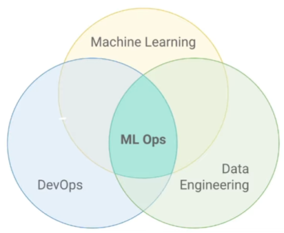
1.1. MLOps
Not the Exact Definition,
"MLOps is the practice of deploying machine learning models into production"

Correct Definition of MLOps,
"MLOps refers to the practice and discipline within machine learning that aims to unify and streamline the machine learning system development (Dev) and machine learning system operation (Ops). It involves collaboration between data scientists, ML engineers, and IT professionals to automate and optimize the end-to-end lifecycle of machine learning applications."

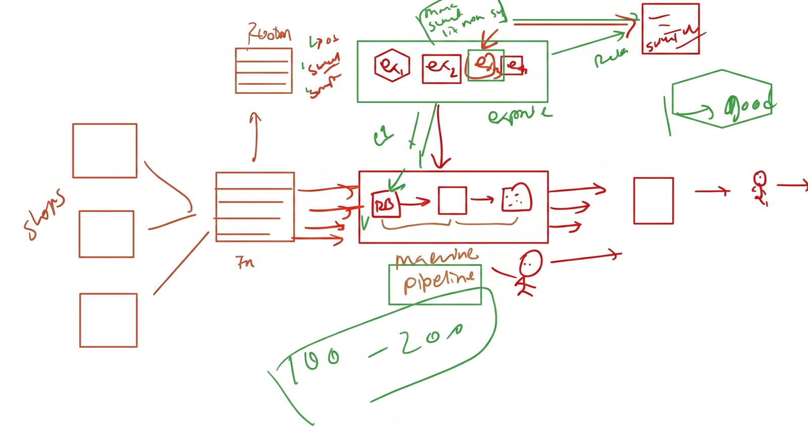

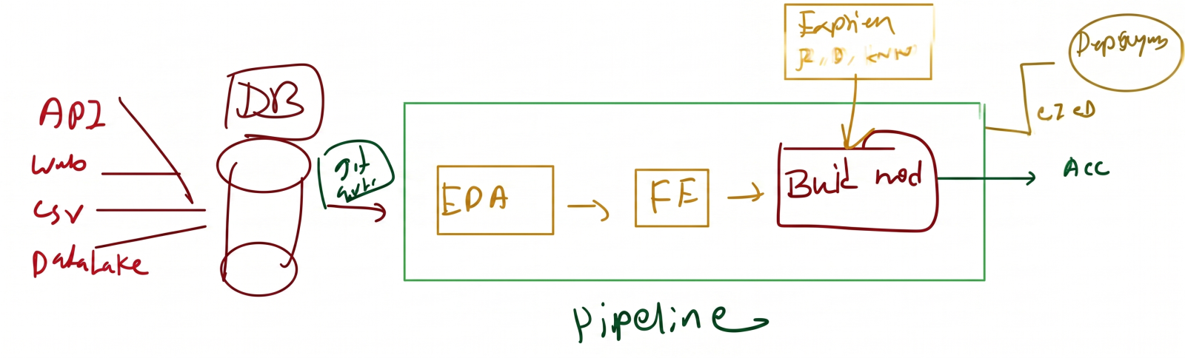

MLOps Flow | Libraries | YouTube Content
1. Data Management – For Data Eng  Build & Track ML Piplines – for ML Engineers  2. Version Control  3. Automation (Pipeline)  4. Experiment Tracking  5. CI/CD  6. Monitoring  7. Retraining | - DVC  - Git & GitHub  - AWS Sagemaker  - MLFlow  - Jenkins, Github Actions  - Grafana  - AirFlow | 1. Linux for MLOps  2. Git & GitHub  3. DVC  4. Cloud  5. MLFlow  6. Docker  7. ML Project  8. CI/CD  9. Kubernetes  10. AWS Sagemaker  11. Grafana

